**Secondary Sources, A.I., and Plagiarism**

There are contradictions in academic writing.

Writers must:

… show they have done research …

… but they must write something new and original.

…use experts and authorities to get information …

…but that information must either be improved or disagreed with.

… improve their English by mimicking what is heard and read …

… but they must use their own words and not mimic too closely.

… show when they have used other people’s ideas …

… but make their own significant contribution.

What is plagiarism? Here is a definition:

**Plagiarism is the practice of taking someone else’s work or ideas**

**and passing them off as one’s own.**

The part of “**someone else’s work or ideas**” includes:

1. just copying the idea

2. paraphrasing the idea too closely

3. the someone = A.I.

Actions that are considered plagiarism or cheating:

1. Buying, stealing, or borrowing a paper.
2. Using the source too closely when paraphrasing.
3. Hiring someone to write your paper.
4. Building on someone’s ideas ***without citation*** (on purpose or on accident).
5. Using A.I. (like ChatGPT) when your instructor clearly says do not use it.

**In most academic situations,**

**plagiarism or cheating = course failure,**

**semester failure, or expulsion from school.**

A.I. (like Chat GPT) is nothing more than a tool. It is a good tool for **some situations**, but it is not the right tool for **all situations**. Students need to learn how to use the tools, as there is **appropriate use of a tool** and **inappropriate use of a tool**.

Example: just because a hammer is a good tool does not mean it is the right tool when you have screws instead of nails.

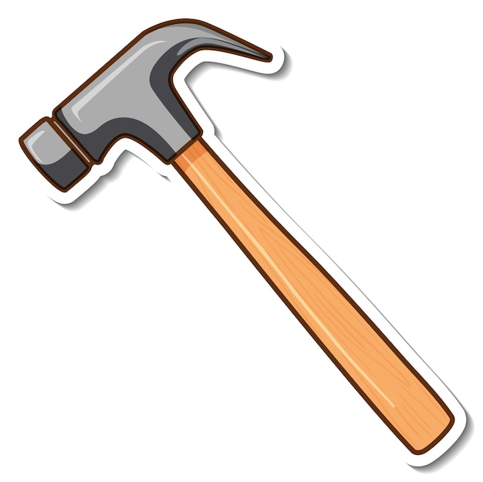

Why not use A.I. or ChatGPT when writing an English essay or report?

Using A.I. or ChatGPT for English writing means:

1. Students are **not applying** their English abilities.

2. Students are **not showing** what they know about English.

3. Students are **not improving** their English abilities when writing.

4. Instructors **want to grade students**, not A.I. or ChatGPT.

5. Students have difficulty distinguishing **good A.I. output** from **bad A.I. output**.

**Exercise for Practice**

Deliberate Plagiarism / Cheating Possibly Accidental Plagiarism / Cheating

<-------------------------------------------------------------------------------------->

Here are some example situations. Is the writer in danger of plagiarizing or cheating? Put a ✔️ if a citation / reference / quotations marks are needed. Explain your answers.

1. _____ You are writing new ideas about your own experiences.

2. _____ You are explaining ideas from a newspaper article about which you disagree.

3. _____ You use some information from a website, but you do not use the exact same words.

4. _____ You have no way of expressing the exact meaning of a text without using the original source exactly word for word.

5. _____ You want to include in your report or essay a story that one of your classmates told about her experiences.

6. _____ The quote you want to use is too long, so you do not use all of it.

7. _____ You really like the particular phrase somebody else made up, so you use it.

8. _____ You use A.I. to translate a webpage into English, and then you use the English on that page in your report.

9. _____ You use any A.I. or ChatGPT when your instructor told you not to.

10. _____ You use Microsoft WORD’s spellchecker and grammar checker when writing your report.